# QUESTIONS

**Q1.** Write a script (***yourfirstname_P1.m***) to solve system of linear equations of three variables.

x + y + z + w = 13  
2x + 3y − w = −1   
−3x + 4y + z + 2w = 10  
x + 2y − z + w = 1



* 1. By using matrices.

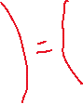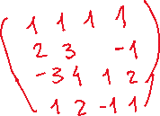

* 1. By using symbolic.

The output on command window should be:

*>> yourname – ID Problem 1*

*By using matrices:*

*x1 =…*

*y1 =…*

*z1 =…*

*w1=…*

*By using symbolic:*

*x2 =…*

*y2 =…*

*z2 =…*

*w2=…*

**Q2.** Write a MATLAB script file (***yourfirstname_Q2.m***) to:

1. Plot 2 line $f\left(x\right)= -{6x}^{2}+x+120$ and $g\left(x\right)= -x^{3}{ + 7x}^{2}-10 x+5$
2. Find the area below $f\left(x\right)$ and $g\left(x\right)$ over the interval $-1≤x≤2$
3. 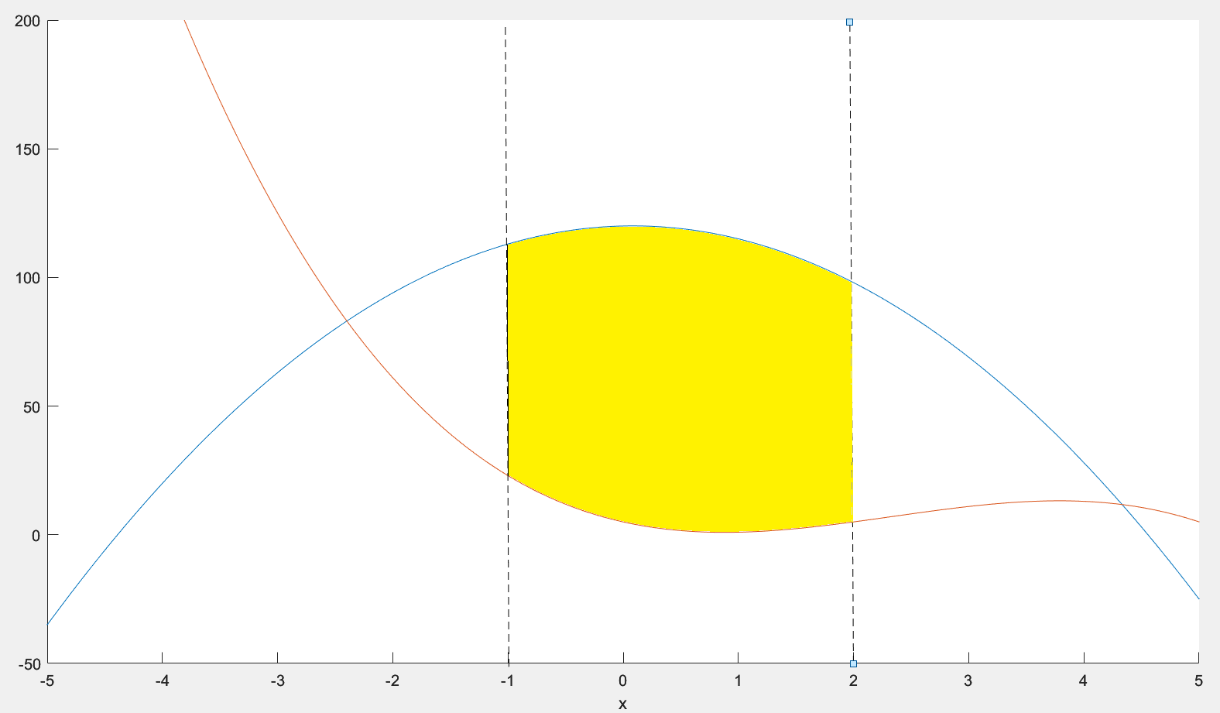

**Q3.** Consider the following Normal Distribution and write a script to solve the corresponding integral:

$$d=\int_{a}^{b}{\frac{1}{\sqrt{2π{}^{2}}}e^{-\frac{{(x-μ)}^{2}}{2{}^{2}}}}$$

With Variance ${}^{2}$ equals to 1 and the Mean $μ$ equals to 0.  
Write script (***yourfirstname_P3.m***) :

1. Find integration d(x) (indefinite integral).
2. Plot d(x) in range x [ -5 5] **(The title of figure should be your name-ID Problem 3.b)**.
3. What is the value of d when a and b equal to -30 and 50, respectively? (convert value to double precision by double() command).

**Q4.** Given the text file "**grade.txt**" on Blackboard ( \Assignments\Final ), where the first column represents the Name of student and the second to ninth columns represent HW1, HW2, HW3, HW4, HW5, HW6, Midterm, and Final respectively. Write a MATLAB file to determine the number of students who fail this class. A student is considered to have failed if their total grade is less than 50. The total grade is calculated as :

Total_grade= Average of HW *30% + Midterm*30% +Final*40%

**Q5. polyfit**

Calculating the flow of water through a culvert is difficult. The reason is the flow channel is not uniform. The following data were collected from the actual culvert:

|  |  |
| --- | --- |
| Height of water level (m) | Flow (m3/s) |
| 0 | 0 |
| 1.7 | 2.6 |
| 1.9 | 3.6 |
| 2.6 | 4.3 |
| 2.9 | 6.2 |
| 4 | 11.5 |
| 5.2 | 30.6 |

1. Compute the best fit for 2nd degree polynomial (quadratic) for the above data.

Print out the coefficient of polynomials. The output on command window should be:

1. Plot actual data and fit model ( 2nd degree polynomial) on the graph **(The title of figure should be your name-ID Problem 2.b)**.
2. Calculate the sum of the squares of the errors of this model. Calculate the flow rate for following heights of level of water
   * 8m
   * 10m
   * 14m

(Hint: use polyval and polyfit commands)

*>> yourname – ID Problem 5.m*

>> p = … … …

*Error=….*

*F8m=….*

*F10m=…..*

*F14m=…..*

- END –

# ANSWERS

|  |
| --- |
| **Q1.** |
| clear  clc  syms x2 y2 z2 w2  one=x2+y2+z2+w2==13;  two=2*x2+3*y2-w2==-1;  three=-3*x2+4*y2+z2+2*w2==10;  four=x2+2*y2-z2+w2==1;  [x2 y2 z2 w2]=solve(one,two,three,four);  A=[1 1 1 1; 2 3 0 -1; -3 4 1 2; 1 2 -1 1];  B=[13; -1; 10; 1];  C=inv(A)*B;  fprintf('By using matrices \r')  fprintf('x1= %4.2f \r',C(1))  fprintf('y1= %4.2f \r',C(2))  fprintf('z1= %4.2f \r',C(3))  fprintf('w1= %4.2f \r',C(4))  fprintf('By using sympolic \r')  fprintf('x2= %4.2f \r',double(y2))  fprintf('y2= %4.2f \r',double(z2))  fprintf('z2= %4.2f \r',double(w2))  fprintf('w2= %4.2f \r',double(x2)) |
| **Q2.** |
| clear all  clc  cla  syms x  f=-6*x^2+x+120  g=-x^3+7*x^2-10*x+5  hold on  ezplot(f)  ezplot(g)  int(f-g,1,2) |
| **Q3.** |
| clear  clc  v=1;  u=0;  syms x  d=(1/(sqrt(2*pi*v))*exp(-((x-u)^2)/2*1));  da=int(d,x)  ezplot(da,[-5 5])  title('YourName ID Problem 3b')  dxx=int(d,x,-30,50);  dc=double(dxx) |
| **Q4.** |
| clear all  clc  count=0;  [name HW1 HW2 HW3 HW4 HW5 HW6 HW7 Mid Final]=textread('grade.txt','%s %f %f %f %f %f %f %f %f %f');  for i=1:length(HW1)  total_grade(i)=mean([HW1(i),HW2(i),HW3(i),HW4(i),HW5(i),HW6(i),HW7(i)])*0.3+Mid(i)*0.3+Final(i)*0.4;  if total_grade (i)<50  count=count+1;  end  end  count |
| **Q5.** |
| clc  clear  h=[0 1.7 1.9 2.6 2.9 4 5.2];  F=[0 2.6 3.6 4.3 6.2 11.5 30.6];  %%a%%  p=polyfit(h,F,2)  %%b%%  hold off  hold on  plot(h,F,'o');  xi = linspace(0,14,100);  yi = polyval(p, xi);  plot(xi,yi);  %%c%%  Ffit=polyval(p, h);  Error =sum((F-Ffit).^2)  F8m=polyval(p,8)  F10m=polyval(p,10)  F14m=polyval(p,14) |